**Project Development Phase**

**Model Performance Test**

|  |  |
| --- | --- |
| Date | 10 November 2022 |
| Team ID | PNT2022TMID36186 |
| Project Name | Project -  Statistical Machine Learning Approaches to Liver Disease Prediction |
| Maximum Marks | 10 Marks |

**Model Performance Testing:**

Project team shall fill the following information in model performance testing template.

|  |  |  |  |
| --- | --- | --- | --- |
| **Synod.** | **Parameter** | **Values** | **Screenshot** |
|  | Metrics | **Regression Model:** SVM – 0.7606837606837606,  KNN -0.6495726495726496,  KNN ACCURACY-0.6495046495726496,  **Classification Model:** Confusion Matrix – array([[77,22],[12,6]]  Accuracy Score- 0.6495046495726496 & Classification Report – refer screenshot | ATTACHED BELOW |
|  | Tune the Model | Hyper parameter Tuning -  Validation Method - | ATTACHED BELOW |

**1. METRICS:**

### Model Evaluation: ACCURACY SCORE OF SVM

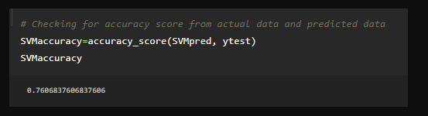

**ACCURACY_SCORE OF RANDOM FOREST CLASSIFICATION:**

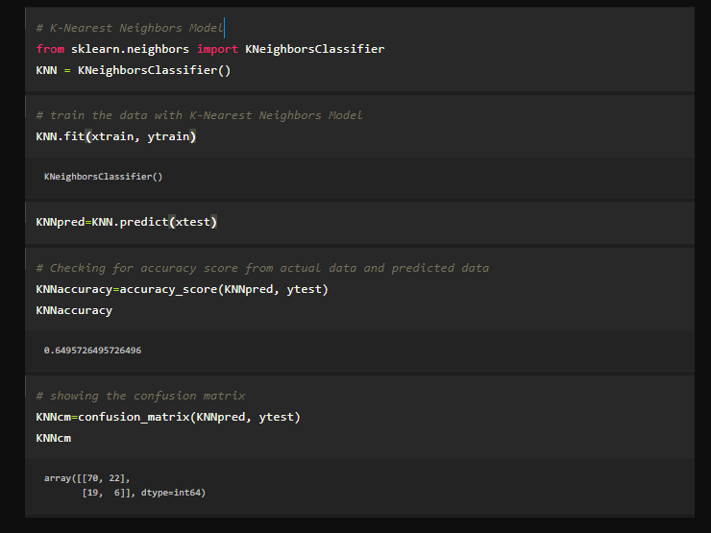

**ACCURACY_SCORE OF KNN CL ASSIFICATION:**

